**Menu Structure**

The menu structure of the DS-7600-S Series NVR is as followed:

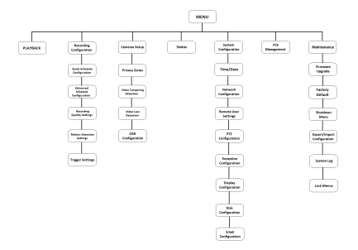

**Startup and Shutdown**

Proper startup and shutdown procedures are crucial to expanding the life of your NVR.

To startup your NVR:

**1.** Ensure the power supply is plugged into an electrical outlet. It is HIGHLY recommended that an Uninterruptible Power Supply (UPS) be used in conjunction with the unit. The Power indicator LED on the front panel should turn red, indicating the unit is receiving power.

**2.** Connect the NVR to a VGA monitor. You will only see the NVR menu system, when it’s connected to a VGA monitor.

**3.** Press the POWER switch on the back rear panel. The Power indicator LED should turn blue. The unit will begin to start.

**4.** After startup, the Power indicator LED will remain blue.

There are two proper ways to shut down the NVR.

**Option 1: Standard Shutdown**

**1.** Enter the Shutdown menu by going to Main Menu > Maintenance > Shutdown.

**2.** Select the Shutdown button.

**3.** Click the Yes button.

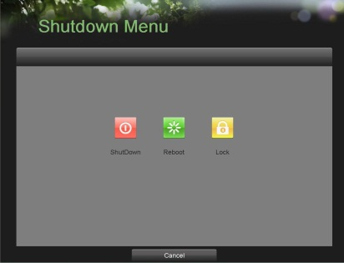

**Option 2: Manual Shutdown**

**1.** Press and hold the POWER button for 3 seconds.

**2.** Enter the administrator’s username and password in the dialog box for authentication.

**3.** Click the Yes button.

**4.** Turn off switch on rear panel

*Note:* Do not press the POWER button again when the system is shutting down.

**Formatting a Disk**

A newly installed hard disk drive (HDD) must be first formatted before it can be used with your NVR.

***Note:*** Formatting the disk will erase all data on it.

To format a new disk:

**1.** Enter the Disk Management menu by going to Main Menu > System Configuration> Disk Management.

**2.** Select a disk to format. A disk that has not been formatted will show Error Detected as its status. If the disk is one that is newly installed, the status of the drive will show up as Non-Active and the Reformat button will change to the Add button.

**3.** Click the Add button.

**4.** A confirmation message will appear on the screen. Click the Yes button to continue formatting process.

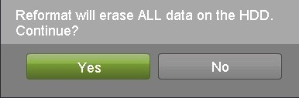

**5.** A format progress bar will be shown on the menu. After the disk has been formatted, the status of the disk will change to Active.

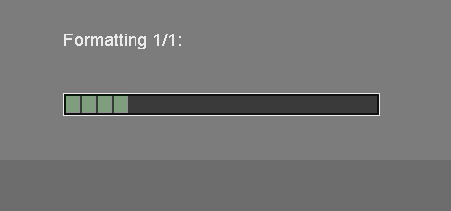

**6.** Click the Done button to exit out of Disk Management.

**Setting Date & Time**

It is extremely important to setup the system date and time to accurately timestamp recordings and events.

To setup date and time:

**1.** Enter the Time/Date menu by going to Main Menu> System Configuration > Time/Date.

**2.** Enter the correct date and time.

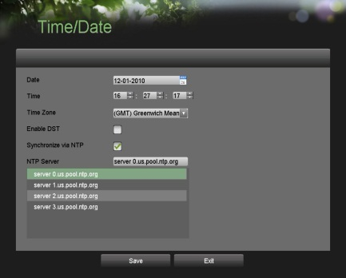

**3.** Click the Save button to save the setting.

**Setting Network**

**1.** Enter the Network Configuration menu by going to Main Menu > System Configuration > Network Configuration.

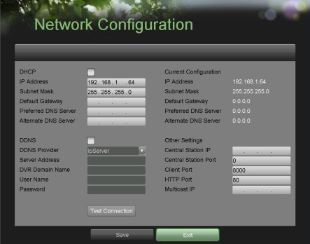

**2.** The current network settings are displayed on the right side of the menu.

**3.** If you have a DHCP server running and would like your NVR to automatically obtain an IP address and other network settings from that server, check the DHCP checkbox.

**4.** If you would like to configure your own settings, enter the settings for IP Address, Subnet Mask and Default Gateway.

**5.** After all settings have been configured; you may test the connection by clicking the Test Connection button. A confirmation message will pop up if the network is working properly.

**Add/Remove Cameras**

To add an IP camera:

**1.** Enter the Add/Remove Cameras menu by going to Main Menu > Cameras Setup > Add/Remove Cameras.

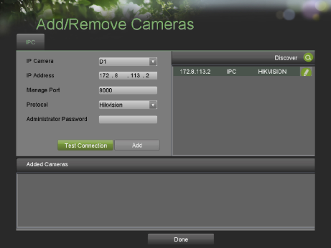

**2.** If an IP camera and NVR are in same LAN. IP cameras will be automatically previewed and recorded in NVR. Please find the firmware for IP camera in CD.

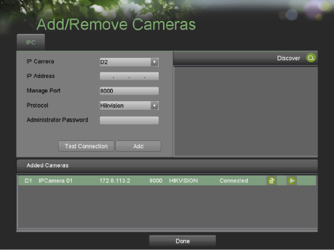

**3.** You can preview image on cameras by clicking  icon. By clicking  icon you may also remove an IP camera.

**Recording**

To setup quick recording schedule:

**1.** Enter the Quick Schedule Configuration menu by going to Main Menu > Recording Configuration> Quick Schedule Configuration.



**2.** Select the camera to configure from the camera drop down menu. If all the cameras are to be configured with the same settings, select All Cameras from the list.

**3.** Check the Enable checkbox to enable the recording schedule. If the checkbox is unchecked, the recording schedule will be disabled.

**4.** Check the 24/7 checkbox if you would like to record continuously or on event for 24 hours a day, 7 days a week. If you wish to schedule different time frames for Monday through Sunday, leave the 24/7 checkbox unchecked and skip to step 6.

**5.** Select Recording Type for 24/7 recording and move on to step 8. Recording type includes Continuous for continuous recording or On Event for recording when an event is triggered (i.e. from detected motion).

**6.** Select the start and stop time for each day of the week. The start and stop time are listed using a 24 hr cycle (i.e. 18:00 is equivalent to 6:00pm).

**7.** Select Recording Type for each day of the week. Recording type includes Continuous for continuous recording or On Event for recording when an event is triggered (i.e. from detected motion) for the selected time period.

**8.** Select the Save button to save the schedule settings and select Exit to return to the previous menu. Selecting the Exit button without clicking Save will quit out of the menu without saving settings.

***Note:*** On Event recordings are recordings that are triggered from motion detection and/or from an external alarm.

**Playback**

**Playback from Search**

**1.** Enter the Playback menu by going to Main Menu > Playback.

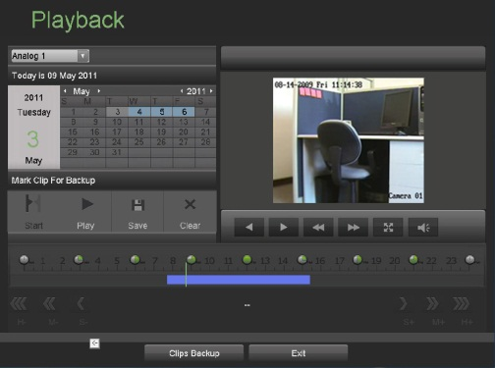

**2.** Set the search parameters by selecting cameras to search and date to search on.

**3.** The search results will be shown on the timeline with blue bars designating recorded files.

**4.** Select file and click the Play button to begin playback.

**5.** Click  button to enter full screen mode.

***Note:*** In full screen mode, you can select multiple channel playback.

**Playback from System Log**

**1.** Enter the System Logs menu by going to Main Menu > Maintenance > System Logs.

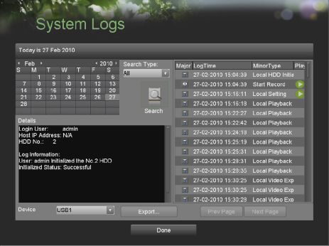

**2.** Select date from the Calendar to search for system logs in.

**3.** Select Search Type.

**4.** Click the Search button.

**5.** A list of results with your search criteria will be displayed. If applicable, select the video log to playback and click Play.

**6.** The recording will begin to play in the Playback interface.

**Backup**

Recorded files can be backed up to various devices, such as USB flash drives, USB HDDs or a DVD writer.

To export recorded files:

**1.** Enter the File Management menu by going to Main Menu > System Configuration > File Management

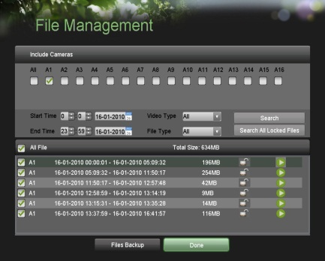

**2.** Select desired parameters to search for files to backup.

**3.** Select the files to backup. You may also click the Play button to verify that these files are indeed the ones you would like to backup. The total size of the files will also be shown on this menu.

**4.** Click the Files Backup button to access the Files Backup Menu.

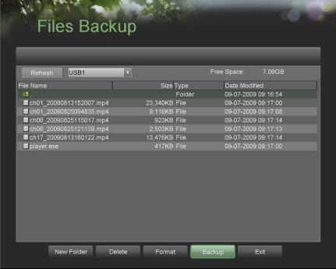

**5.** Select device to backup to from drop-down list (USB Flash Drive, USB HDD, DVD Writer). If backup device is not recognized:

**•** Click the Refresh button.

**•** Reconnect device.

**•** Check for compatibility from vendor.

**6.** The total available free space will be shown. If the free space is not sufficient, delete files from the storage device or insert a device with more available free space.

**7.** Click the Backup button to begin backup process. After the backup has completed, click the OK button.

***Note:*** Video Player software will automatically be copied

on to the device that the recorded files were exported on.

**Using the Front Panel Controls**

Your DVR comes with built-in front panel controls, as shown in the following figure:

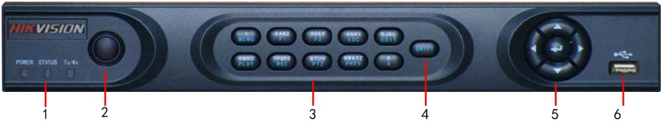

**Figure1. DS-7604 Series DVR Front Panel**

The controls on the front panel include:

1. **Status Indicators**:

* **POWER**: the POWER indicator turns green when DVR is powered up.
* **STATUS**:the indicator: 1. Lights in green when the compound key (SHIFT) is used; 2. Flickers in red when the HDD is reading/writing.
* **Tx/Rx**:TX/RX indictor flickers green when network connection is functioning normally.

1. **IR Receiver:** operation by IR remote control.
2. **Compound Buttons:**

* **1 MENU**: (1) Enter numeral “1”; (2) Access the main menu interface
* **2ABC/F1**: (1) Enter numeral “2”; (2) Enter letters “ABC”; (3) The F1 button when used in a list field will select all items on the list. In PTZ Control mode, it will turn on/off PTZ light.
* **3DEF/F2**:(1) Enter numeral “3”; (2) Enter letters “DEF”; (3) The F2 button is used to cycle through tab pages. It will also bring up the Channel & OSD Position settings.
* **4GHI/ESC**: (1) Enter numeral “4”; (2) Enter letters “GHI”

(3) Exit and back to the previous menu

* **5JKL/EDIT**: (1) Enter numeral “5”; (2) Enter letters “JKL”; (3) Delete characters before cursor;

(4)Select the checkbox and ON/OFF switch; (5) Start/stop record clipping in playback

* **6MNO/PLAY**: (1) Enter numeral “6”; (2) Enter letters “MNO”; (3) Playback, for direct access to playback interface
* **7PQRS/REC**: (1) Enter numeral “7”; (2) Enter letters “PQRS”; (3) Manual record, for direct access to manual record interface; manually enable/disable record
* **8TUV/PTZ**: (1) Enter numeral “8”; (2) Enter letters “TUV”; (3) Access PTZ control interface
* **9WXYZ/PREV**: (1) Enter numeral “9”; (2) Enter letters “WXYZ”; (3) Multi-camera display in live view.
* **0/A**:(1) Enter numeral “0”; (2) switch between input methods (upper and lowercase alphabet, symbols and numeric input)

1. **SHIFT:** Switch of compound keys between the numeric/letter input and functional control.
2. **Control Buttons:**

* **Directional buttons:** In menu mode, the *direction* buttons are used to navigate between different fields and items and select setting parameters. In playback mode, the *Up* and *Down* buttons are used to speed up and slow down record play, and the *Left* and *Right* buttons are used to select the recording 30s forwards or backwards. In live view mode, these buttons can be used to cycle through channels.
* **Enter:** The *Enter* button is used to confirm selection in menu mode; or used to selectcheckbox fields and ON/OFF switch. In playback mode, it can be used to play or pause the video. In single-frame play mode, pressing the *Enter* button will advance the video by a single frame. And in auto sequence view mode, the buttons can be used to pause / resume auto sequence.

1. **USB Interface:** Connects USB mouse or USE flash memory devices.

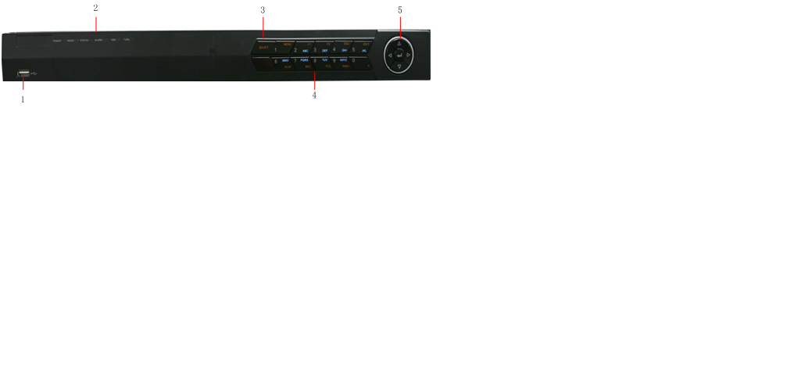

**Figure2. DS-7608NI-S DVR Front Panel**

The controls on the front panel include:

1. **USB Interface:** Connect USB mouse or USE flash memory devices.
2. **Status Indicators**:

* **POWER**: the POWER indicator turns green when NVR is powered up.
* **READY**: the indicator lights in green when the device is running normally.
* **STATUS**: the indicator: 1. Lights in green when the IR remote control is enabled; 2. Lights in red when the compound key (SHIFT) is used.
* **ALARM**: the indicator lights in red when there is sensor alarm occurring.
* **HDD**: the indicator flickers in red when HDD is reading/writing.
* **Tx/Rx**: TX/RX indicator flickers green when network connection is functioning normally.

1. **SHIFT**: Switch of compound keys between the numeric/letter input and functional control.
2. **Compound Buttons:**

* **1 MENU:** (1) Enter numeral “1”; (2) Access the main menu interface.
* **2ABC/F1**: (1) Enter numeral “2”; (2) Enter letters “ABC”; (3) The F1 button when used in a list field will select all items on the list. In PTZ Control mode, it will turn on/off PTZ light.
* **3DEF/F2**:(1) Enter numeral “3”; (2) Enter letters “DEF”; (3) The F2 button is used to cycle through tab pages. It will also bring up the Channel & OSD Position settings.
* **4GHI/ESC**: (1) Enter numeral “4”; (2) Enter letters “GHI”; (3) Exit and back to the previous menu.
* **5JKL/EDIT**: (1) Enter numeral “5”; (2) Enter letters “JKL”; (3) Delete characters before cursor; (4)Select the checkbox and ON/OFF switch; (5) Start/stop record clipping in playback.
* **6MNO/PLAY**: (1) Enter numeral “6”; (2) Enter letters “MNO”; (3) Playback, for direct access to playback interface**.**
* **7PQRS/REC**: (1) Enter numeral “7”; (2) Enter letters “PQRS”; (3) Manual record, for direct access to manual record interface; manually enable/disable record.
* **8TUV/PTZ**: (1) Enter numeral “8”; (2) Enter letters “TUV”; (3) Access PTZ control interface**.**
* **9WXYZ/PREV**: (1) Enter numeral “9”; (2) Enter letters “WXYZ”; (3) Multi-camera display in live view.
* **0/A**:(1) Enter numeral “0”; (2) switch between input methods (upper and lowercase alphabet, symbols and numeric input)**.**

1. **Control Buttons:**

* **Directional buttons:** In menu mode, the direction buttons are used to navigate between different fields and items and select setting parameters. In playback mode, the Up and Down buttons are used to speed up and slow down record play, and the Left and Right buttons are used to select the recording 30s forwards or backwards. In live view mode, these buttons can be used to cycle through channels.
* **Enter:** The *Enter* button is used to confirm selection in menu mode; or used to selectcheckbox fields and ON/OFF switch. In playback mode, it can be used to play or pause the video. In single-frame play mode, pressing the *Enter* button will advance the video by a single frame. And in auto sequence view mode, the buttons can be used to pause / resume auto sequence.

Note: It is important to note that you must click the EDIT button on either the remote or front panel on a text field before you’re able to edit its content. After you’re done entering text, you must hit the ENTER button to be able to move on to the next field.